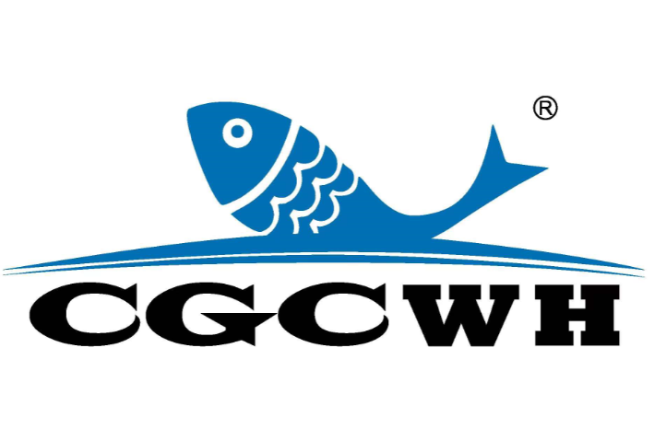 | CGC EXPO 2024  PRE-REGISTRATION FORM  Weihai International Economic and Trade Exchange Center, Weihai, China Oct. 12-14, 2024

Please send the form back to the organizer by E-mail: lijiang@chinafish.cn or by fax: +86-10-5820 3100.

1. PRE-REGISTRATION (NO ENTRY FEE FOR BUYERS)

Your Badge No. of CGC 2023 (No need to fill the blank below if provided):

Contact Information:
Name: (Mr./Mrs./Ms.) Position:
Company:
Address:
Zip Code: Country: E-mail:
Phone: Fax: Web:
Others: (Optional)
Facebook: Instagram: Twitter:
LinkedIn: Youtube:

Registration for your colleagues:
Name: (Mr./Mrs./Ms.) Position:
Name: (Mr./Mrs./Ms.) Position:
Name: (Mr./Mrs./Ms.) Position:
(Please make photocopies if you need more than 4 badges)

Registration Fee:
Free: Registration before Sep.20, 2024
USD 15: On-site registration
2. CATEGORY: (Mandatory)
□ Buyer Wholesaler □ Buyer Retailer □ Manufacturer Representative
□ Association / Organization □ Import and Export Company
□ Guest (Must be approved by the organizer)

3. SERVICES:
You will receive Reservation Forms accordingly, if any of the following services is chosen by you.
- Hotel Reservation □ Visa Invitation Letter □ Interpreter Services
Any questions, please log on our website: www.chinafishshow.org

